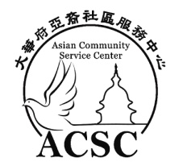
Performance Application
www.ChineseNewYearFestival.org
Feb. 17, 2024 Saturday 10am-6pm

Date of Application: _ __ __ __ __ __
Contact Name: _ __ __ __ __ __ __ __ __ ___ __ __ __ __ __Phone: _ __ __ __ __ __ __ __ _
Organization _ __ __ __ __ __ __ __ __ __ __ __ __ __ __ __ __ __ __ __ __ __ __ __ _
Email: _ __ __ __ __ __ __ __ __ __ __ __ __ __ __ __ __ __ __ __ __ __ __ __ _
Performance Type: _ __ __ __ __ __ __ __ __ __ __ __ __ __ __ __ __ _
Country from: _ __ __ __ __ __ __ __ __ __ __ __ __
How many performers: __ __ ___ __ __ __ __ __ __How long: __ __ ___ __ __ __ __ __ __
Notice: IF you need play music, please try to send us music file by link. If you only has CD, please let us know. Our performance will start from 12pm to 5pm, please provide your prefer performance time if you have.
Since we are 100% volunteer work, we can’t pay for the performers. But, we have some small gift for performers.
Please send us 2-3 performance pictures or video you had before.

Signature: ________________________________ Date: ________________
Please complete and email the form to contact@AsianServiceCenter.org or fax to 703-763-2340

