CHINESE NEW YEAR FESTIVAL 2020, 13th Annual
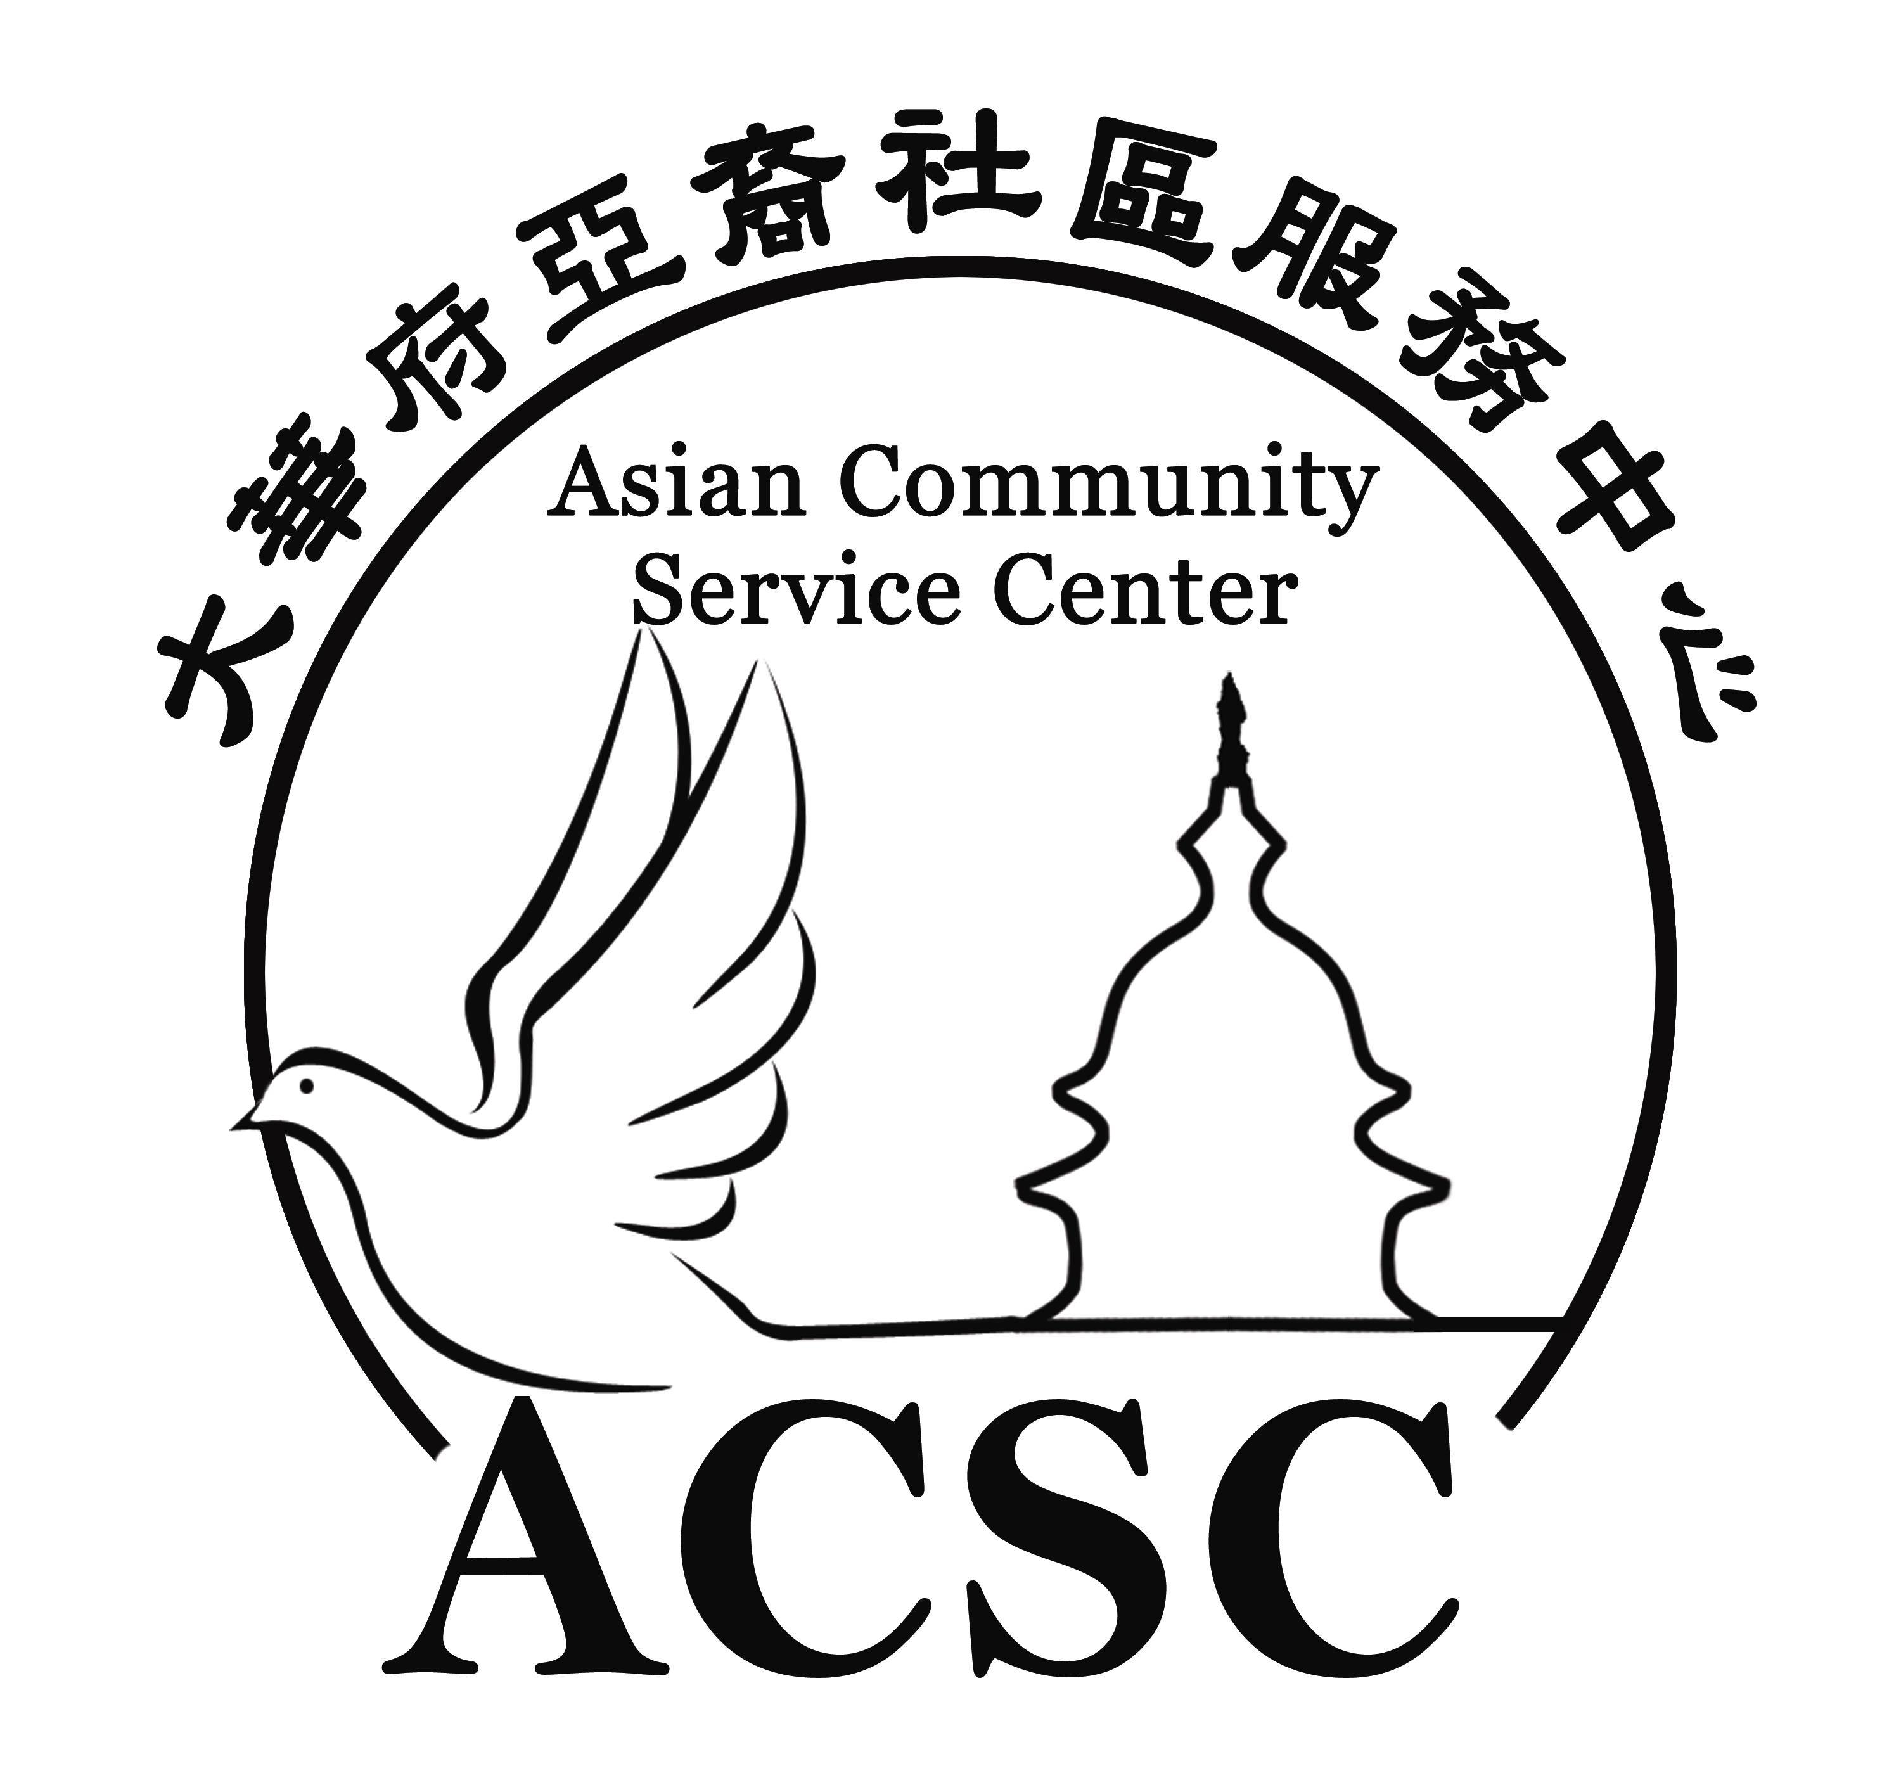

Jan. 25th (Sat.) 10am-6pm (Snow Date: Feb. 8, Sat.)
Luther Jackson Middle School 3020 Gallows Road, Falls Church, VA 22042
www.ChineseNewYearFestival.org

Vendor Name:___________________________________________________________
Booth Sign: __________________________ Contact Person: ____________________
Address: _______________________________________________________________
Phone: ________________ Fax: ______________ Email: _______________________
RETAIIL BOOTH APPLICATION
Booth Option | Description | Price | Subtotal
Art & Crafts | 8’x10’- share a 10’ x 3’ table with another vendor, 2 chairs | $200
 | 16’x10’ - include 10’x3’ table, 2 chairs (can ask for 2 more) | $375
Businesses | 8’x10’- share a 10’ x 3’ table with another vendor, 2 chairs | $250
 | 16’x10’ - include 10’x3’ table, 2 chairs (can ask for 2 more) | $450
Community/  Nonprofits | 8’x10’- share a 10’ x 3’ table with another vendor, 2 chairs | $120
 | 16’x10’ - include 10’x3’ table, 2 chairs (can ask for 2 more) | $200
Ads in event newspaper : 1/4page :$265 ; 1/8pg :$145 ; 1/16pg :$75 ; 1/32pg : $45
FIRST COME FIRST SERVE. TOTAL
List ALL sales items or products/services to be exhibited (add separate if needed) ________________________________________________________________________
________________________________________________________________________
________________________________________________________________________
(Only those listed above may be sold or displayed.)

Amount enclosed: ______________________ Check numbers:___________________

Please return Application and full payment to Asian Community Service Center,
2758 Stone Hollow Dr. Vienna, VA 22180. Checks payable to Asian Community Service Center. Payments are non-refundable. Only application with payment will be processed.

Liability Waiver. The person signing below certifies that he/she has the legal right to act on behalf of the vendor. The vendor including all of its employees, agents and other representatives hereby holds harmless and indemnifies Asian Community Service Center, all sponsors, board members, employees and other representatives of each, for all and any damages or liability incurred as a result of the actions of the vendor in the Chinese New Year Festival 2020. I agree that all representatives acting on the vendor's behalf for any matter pertaining to this event will be subject to all rules herein and directions of ASCS onsite staff as well as applicable law and regulations.

Signature: _______________________________ Date: ________________________

For questions, please call 703-868-1509 fax 703-763-2340 contact@AsianServiceCenter.org
Accepted by Asian Community Service Center:
Name/Title ________________________ Signature: ___________________ Date: ________

