CHINESE NEW YEAR FESTIVAL 2023, 14th Annual
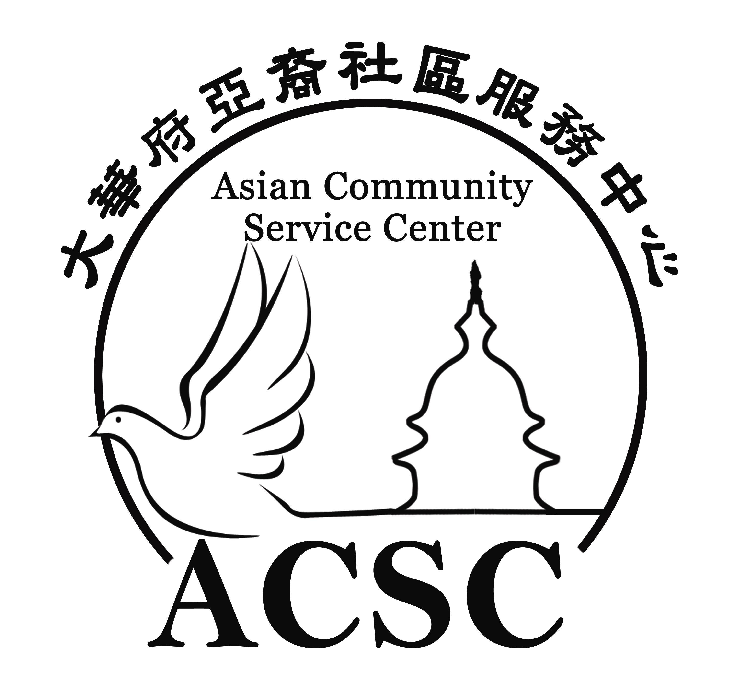

Jan. 14th (Sat.) 10am-6pm
Luther Jackson Middle School 3020 Gallows Road, Falls Church, VA 22042
www.ChineseNewYearFestival.org

FOOD VENDOR APPLICATION
Cost: ____ 16 x10 Booth for $450;
Vendor Name:_______________________________ License ID: _________________
Booth Sign: __________________________ Contact Person: ____________________
Address: _______________________________________________________________
Phone: ________________ Fax: ______________ Email: _______________________
Food and Drinks Items and Price (ACSC reserves right to remove items if no listed)
________________________________________________________________________
______________________________________________________________________________
Will you be grilling?____ Will you need electricity? _____ Volts: __ 110; ___ 220 Amps

Insurance and License. All food vendors must submit proof of the following:
- Food permit/license issued by Fairfax County Health Department.
- Certificate of $1 million insurance policy that names Chinese New Year Festival 2020 and Asian Community Service Center as insureds on the insurance certificate.

Amount enclosed: ______________________ Check numbers:___________________
Please return Application and full payment to Asian Community Service Center, 2758 Stone Hollow Dr. Vienna, VA 22180. Payment must include a $50 separate check for clean-up deposit per booth. Checks payable to Asian Community Service Center. Payments are non-refundable. Only application with payment will be processed. First come first serve.

Liability Waiver. The person signing below certifies that he/she has the legal right to act on behalf of the vendor. The vendor including all of its employees, agents and other representatives hereby holds harmless and indemnifies Asian Community Service Center, all sponsors, board members, employees and other representatives of each, for all and any damages or liability incurred as a result of the actions of the vendor in the Chinese New Year Festival 2023. I agree that all representatives acting on the vendor's behalf for any matter pertaining to this event will be subject to all rules herein as well as applicable law and regulations.

Signature:_______________________________Date:________________________

For questions, contact Tiny : Tel 703-868-1509 fax 703-763-2340 contact@AsianServiceCenter.org

Accepted by Asian Community Service Center:
Name/Title ________________________ Signature: ___________________ Date: ________

